CURRENT ATTORNEY FEE PROCESS

Executive Summary

Since the enactment of Social Security Amendments in 1967, SSA has certified payment, not to exceed 25 percent of past-due benefits, directly to an attorney from a claimant’s pas due Federal Old Age, survivor and Disability Insurance (OASDI) Benefits [Title II of the Social Security Act, also referred to as Retirement, Survivors and Disability Insurance (RSDI)]. SSA also determines and approves fees for non-attorney claimant representative in RSDI cases. SSA does not have the authority to make fee payments directly to non-attorneys in RSDI cases.

Section 406 of the Ticket to Work and Work Incentives Improvement Act of 1999 (Public Law 106-170, also referred to as Ticket to Work Act), requires SSA to collect a user fee to offset the cost of determining and certifying payments directly to attorneys for their claimant representative services. The legislation set the user fee for the calendar year at 6.3 percent of the amount of the fee certified for payment to the attorney. It also required that SSA annually determine the percentage rate of the user fee for years after 2000 in order to obtain full recovery of its costs for this service, not-to-exceed the 6.3 percent.

Schedule AF-1: Summary of Total Costs, Cost Re-assignments, and Cost Re-allocation by SSA Organization and Resulting Intermediate Cost Allocation Rates

A: Reassign General Service Administration (GSA) costs to each component. The GSA components for the Field Offices (RC-S), Program Service Center Operations (PSC), and Headquarters (HQ), are special CAS organization created to capture workyears and costs for space management activities. These activities are funded through a transfer to SSA from GSA of funds originally paid to GSA as Standard Level User Charges (SLUC). To find an accurate figure for total component cost of the attorney fee process, it is necessary to allocate these costs to the appropriate components.

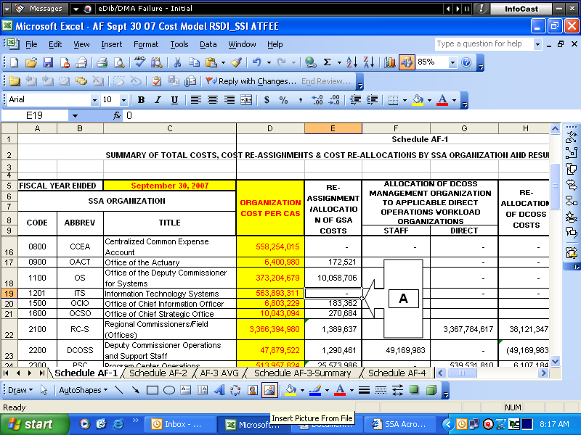

B: Use the GSA allocation rate to split staff costs for Deputy Commissioner of Operations and Support Staff (DCOSS), from direct costs for Regional Commissioners of the Field Offices (RC-S), Program Service Center Operations (PSC), Office of Disability Operations (ODO), Office of International Operations (OIO), and Office of Earnings Operations (OEO).

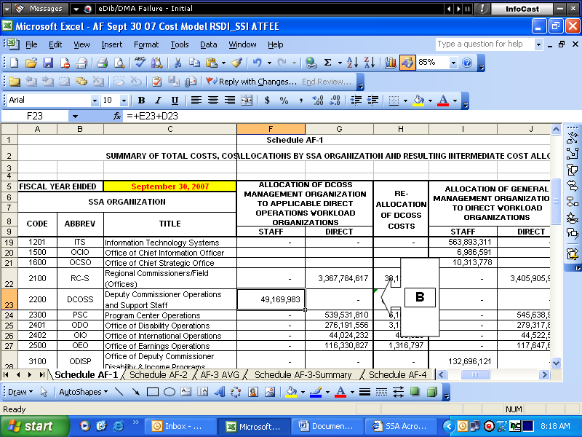

C: Allocate DCOSS staff costs to direct components. DCOSS work is performed to support the direct components. Similarly to the GSA components, it is necessary to have all costs contributing to the attorney fee process allocated proportionately to the direct components.

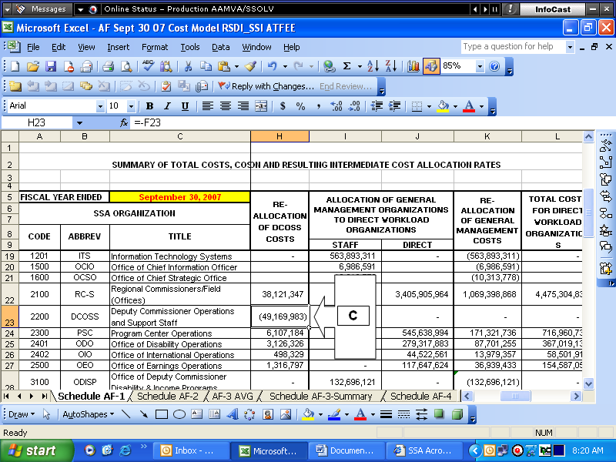

D: Allocate General Management (GM) staff costs to direct components. GM work is performed to support the direct components. Similarly to the GSA components, it is necessary to have all costs contributing to the attorney fee process allocated proportionately to the direct components.

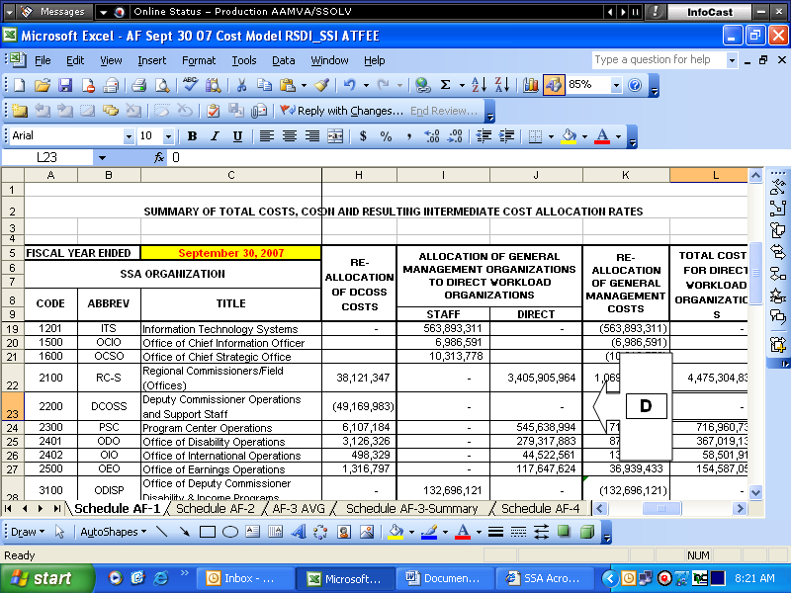

E: Determine total costs for each direct component. Though the Cost Analysis System (CAS) is able to calculate the individual component costs as well as SSA total costs, it is unable to perform the necessary allocation of GSA and staff costs to determine a total cost applied to a specific effort. The reallocation process in steps A through D provides the necessary totals used towards the attorney fee process. These figures will be used to determine the total claimant fee process cost in schedule AF-4 and AF-10.

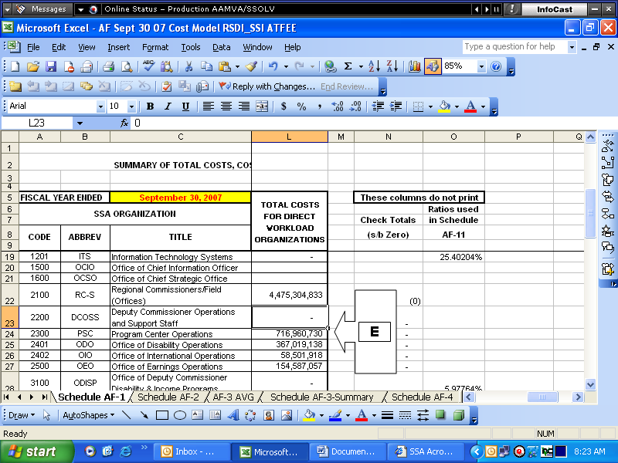

Schedule AF- 2: Case Representation Data

F: Use the Office of Disability Adjudication and Review (ODAR) Participation Report to determine attorney representation and case decisions by program. By utilizing the ODAR Participation Report, the percentage of cases with and without attorney and non-attorney representation is determined. The percentage of total RSI, DI, SSI, and concurrent cases is also calculated. Note: ODAR is the only component with means to collect this data. Therefore, this information is used for RC-S, PSC, ODO, and OIO as a representation of “best available data”.

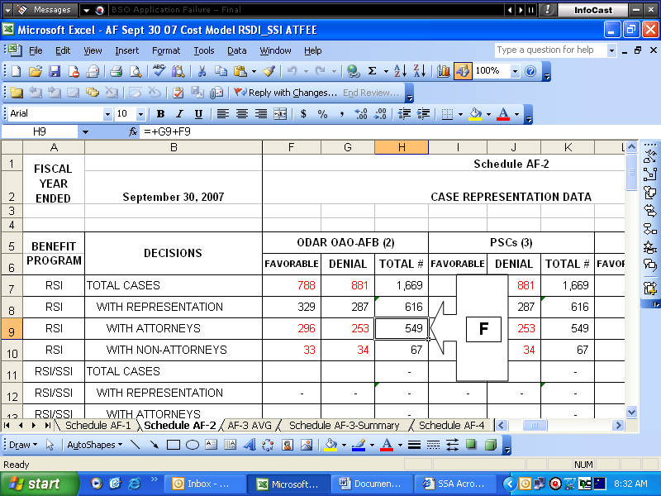

Schedule AF- 3 AVG: Special Studies Tallies

G: Use the Attorney Fee Special Study Report to identify the tallies that represent RSDI and SSI reconsideration, hearings and appeals, and effectuation claims with attorney involvement. By performing a special study, RC-S is able to identify the frequency of activities related to the attorney fee process.

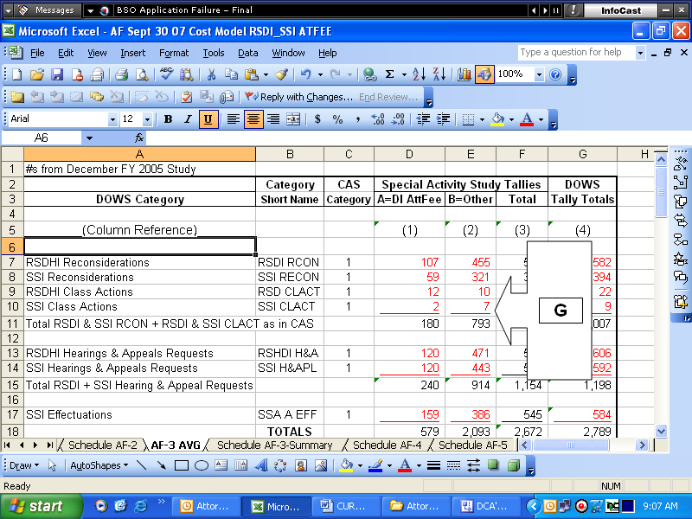

H: Use the monthly RC-S DOWS tallies collected from WMT to identify the total RSDI and SSI reconsideration, hearings and appeals, and effectuation claims with attorney involvement. Schedule AF-3 AVG is used as a means to collect data. The data analysis is performed in schedule AF-3 Summary. Note: IWMS transitioned to WMT in 2007.

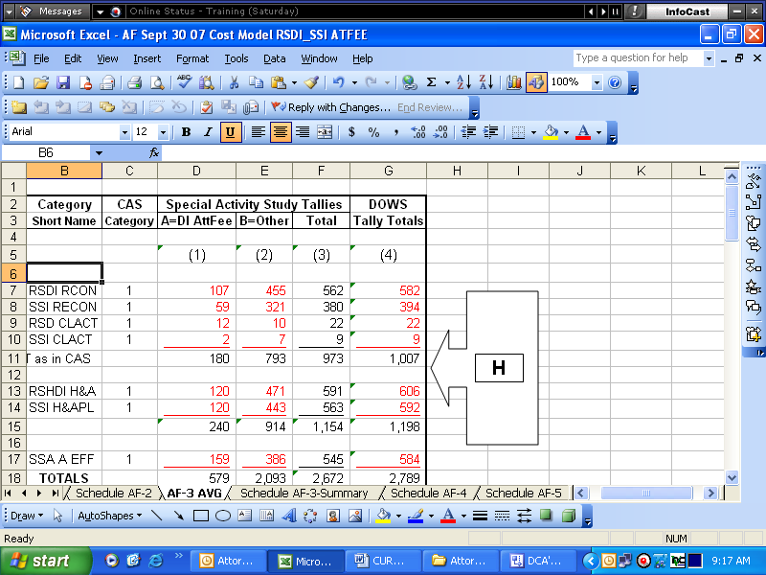

Schedule AF- 3 Summary: Summary of Special Studies Tallies

I: Combine the two months of special study results and DOWS tallies to determine the average number of claims. This figure is then used as a basis for analysis. Note: To provide valid results, a minimum of two months is required. If the results are found to be invalid by the Office of the Actuary, an additional month of special studies is performed. Accuracy is determined by comparing the special study tallies to the DOWS tally totals (column H).

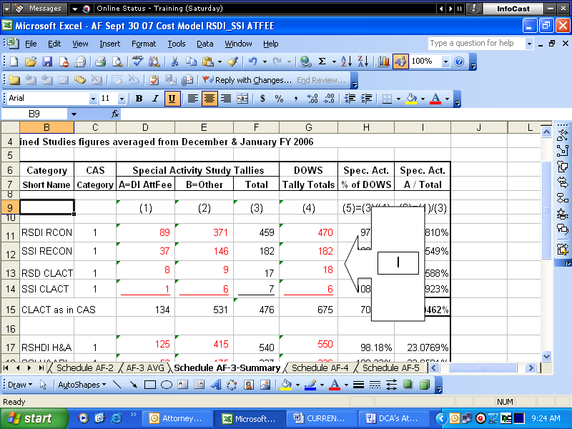

J: Determine the percent of cases in RC-S that have attorney representation. These figures will be used to determine the total claimant fee process cost by activity in schedule AF-4 and AF-10.

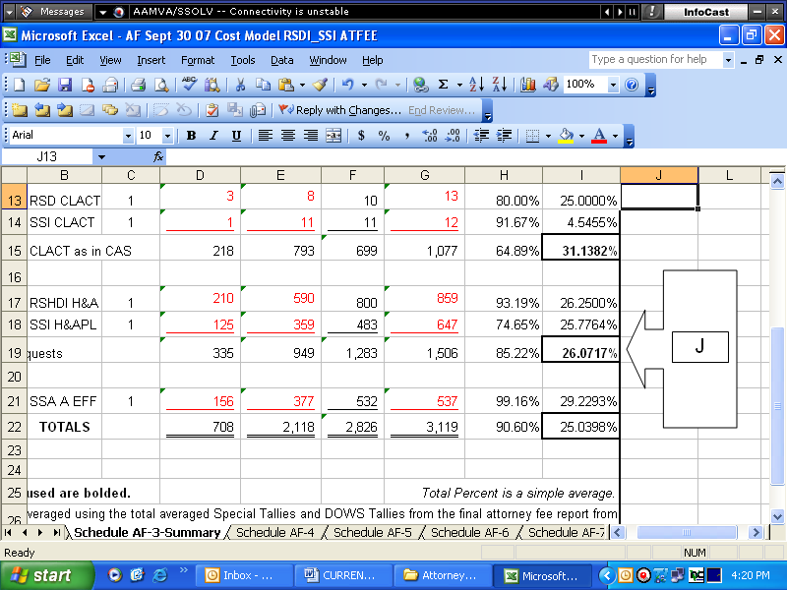
Schedule AF- 4: Calculation of Field Offices Total Costs to Administer Attorney Fee Process

K: Use the CAS S3-1 report for RC-S to determine the RC-S RSDI and SSI costs incurred for processing reconsiderations and hearing and appeals.

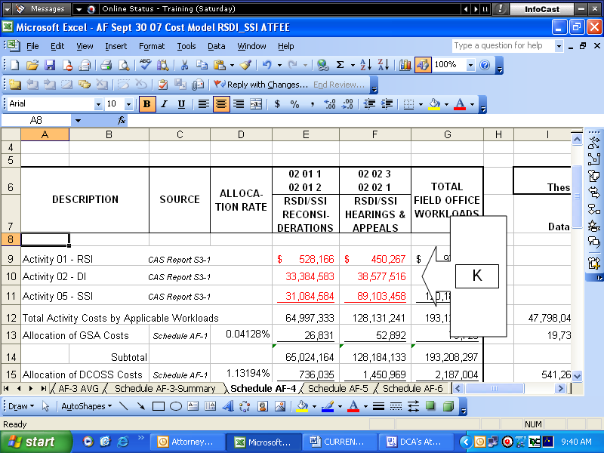

L: Use the GSA, DCOSS, and GM Staff allocation rates found in schedule AF-1 to determine the amount of staff overhead to be added to the S3-1 summary costs. To find an accurate figure for total component cost of the attorney fee process, it is necessary to allocate these costs to the appropriate components.

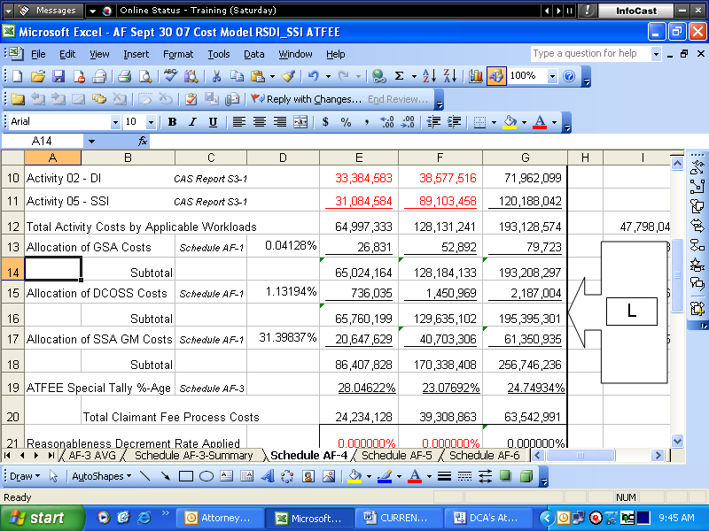
M: Calculate a total RC-S cost for the attorney fee process. This calculation will provide the total costs associated with these claims for RC-Field by including cost incurred by support staff and GSA to assist in this process.

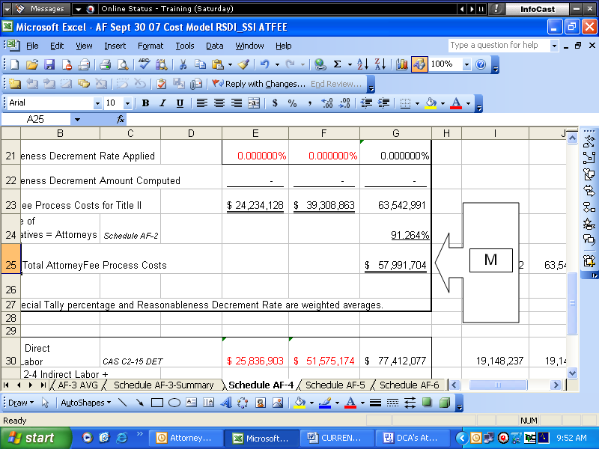

Schedule AF- 5: ODAR Staff Support Operations/Management Overhear for Fiscal Year

N: Use the ODAR Staffing Report to determine the percent of ODAR support staff to total full-time permanent and other employees for the fiscal year. This report measures the quantity of employees working for specific offices within ODAR.

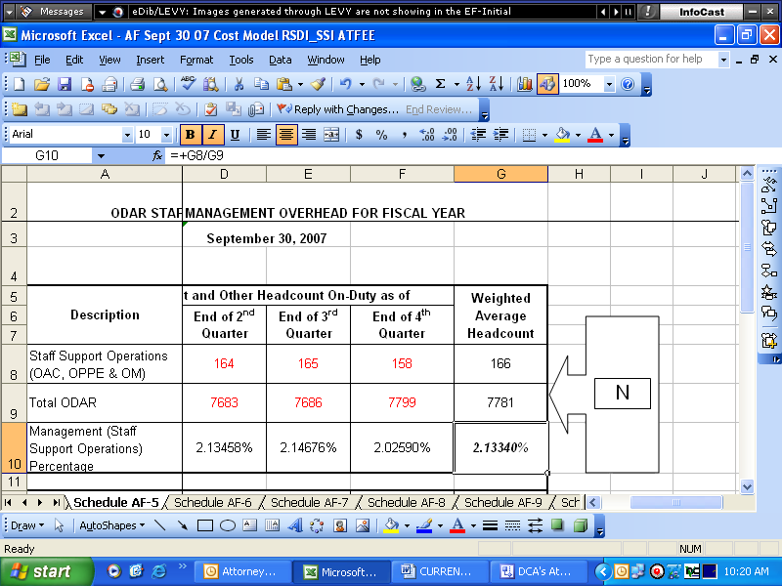

O: Calculate the ODAR direct costs to determine the management overhead rate. These figures will be used to determine the total claimant fee process cost by activity in schedule AF-7.

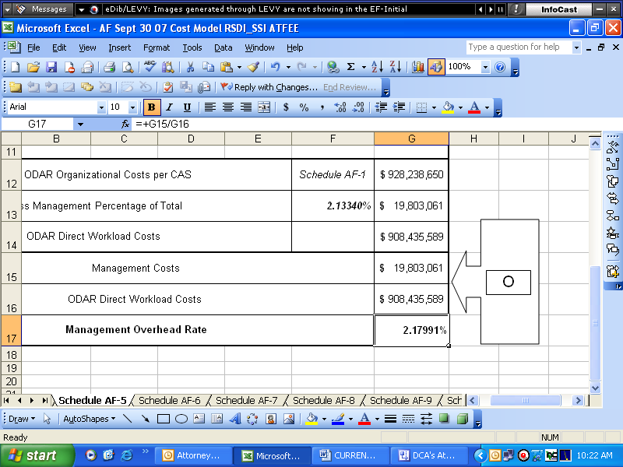

Schedule AF- 6: Attorney Fee Branch Percentage of ODAR Headcount

P: Use the ODAR Staffing Report to determine the percent of ODAR attorney fee branch staff to total full-time permanent and other employees for the fiscal year. This report measures the quantity of employees working for the attorney fee branch within ODAR.

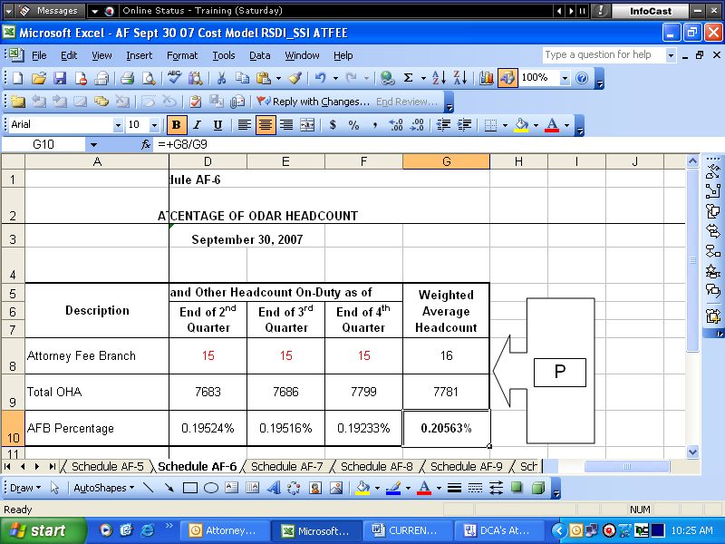

Schedule AF- 7: Calculation of Office of Disability Adjudication and Review Total Costs to Administer Attorney Fee Process

Q: Use the CAS S3-1 report for ODAR to determine the total RSDI and SSI costs.

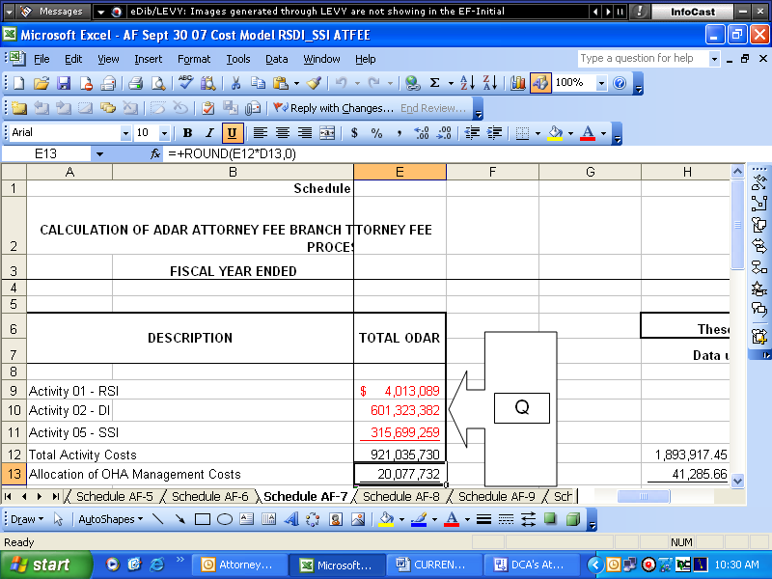

R: Use the GM Staff allocation rates found in schedule AF-1, and ODAR management overhead rate found in schedule AF-5 to determine the amount of staff overhead to be added to the S3-1 summary costs. To find an accurate figure for total component cost of the attorney fee process, it is necessary to allocate these costs to the appropriate components. This calculation will provide the total costs associated with these claims.

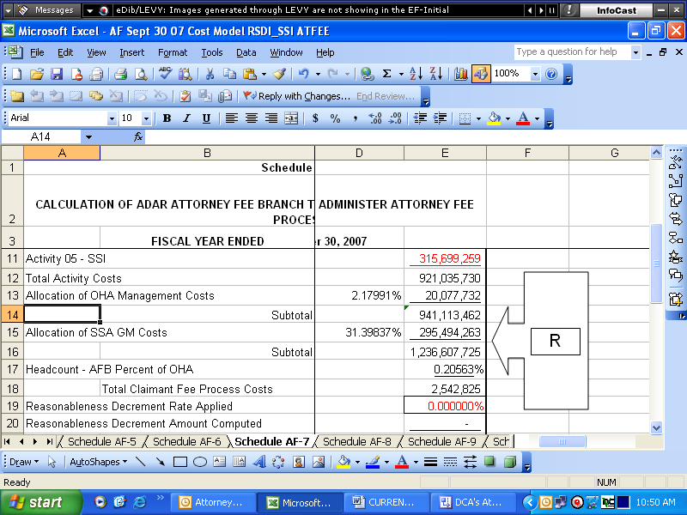

S: Calculate a total ODAR cost for the attorney fee process. This calculation will provide the total costs associated with these claims for ODAR by including cost incurred by support staff and management overhead to assist in this process.

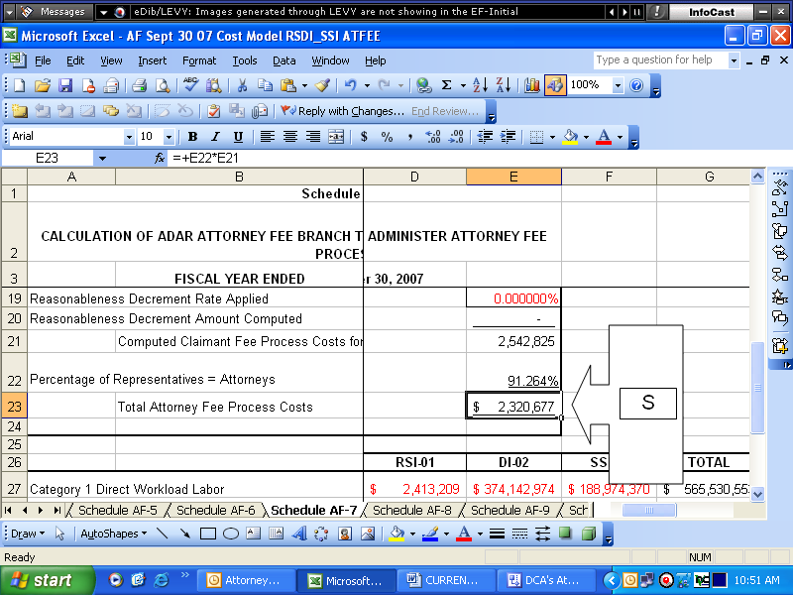

Schedule AF- 8: PCACS Sample Tallies for CAS Workload Function: 02021 ALJ Reversals/Appeals

T: Combine the PCACS sample TOELS from PSC, ODO, and ODIO to determine a total for each attorney or non-attorney related action. These TOELS will be used in schedule AF-8 to determine a percent of the attorney fee process handled by PSC, ODO, and OIO within the processing centers.

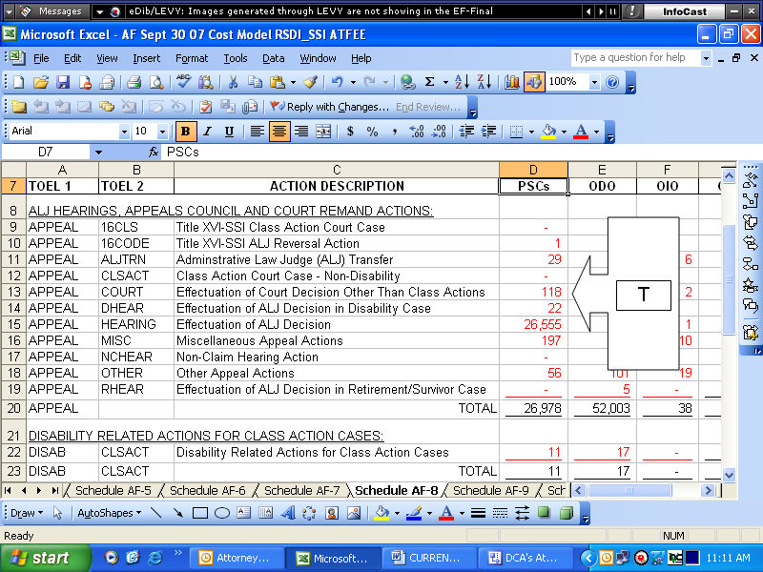

Schedule AF- 9: ATFEE PCACS Samples Percentages of 02021 ALJ Reversals/Appears to Totals

U: Use the data from schedule AF-8 to determine the percent of total ATFEE tallies to ALJ/Reversals tallies for PSC, ODO, and OIO.

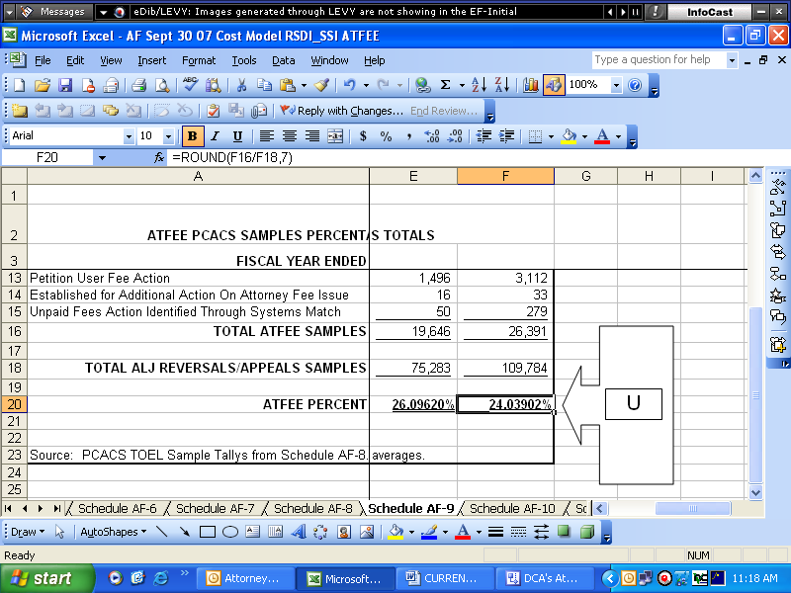

Schedule AF- 10: Calculation of Processing Service Centers Total Costs to Administer the Attorney Fee Process

V: Use the CAS S3-1 report for PSC, ODO, and OIO to determine the total RSDI and SSI costs.

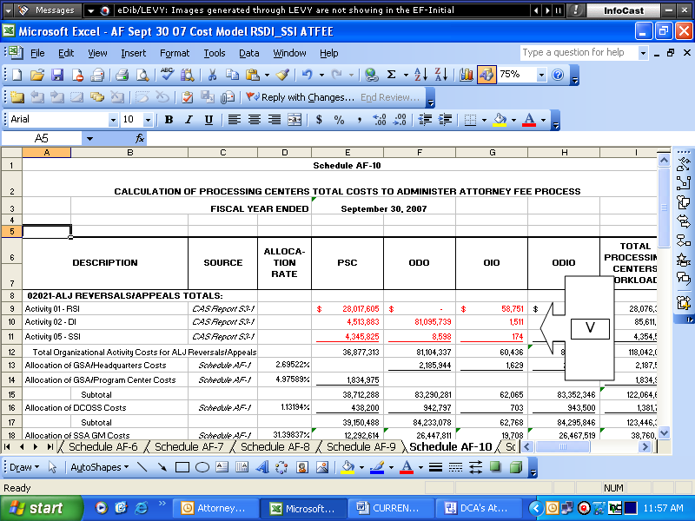

W: Use the GSA, DCOSS, and GM Staff allocation rates found in schedule AF-1 to determine the amount of staff overhead to be added to the S3-1 summary costs. To find an accurate figure for total component cost of the attorney fee process, it is necessary to allocate these costs to the appropriate components. This calculation will provide the total costs associated with these claims.

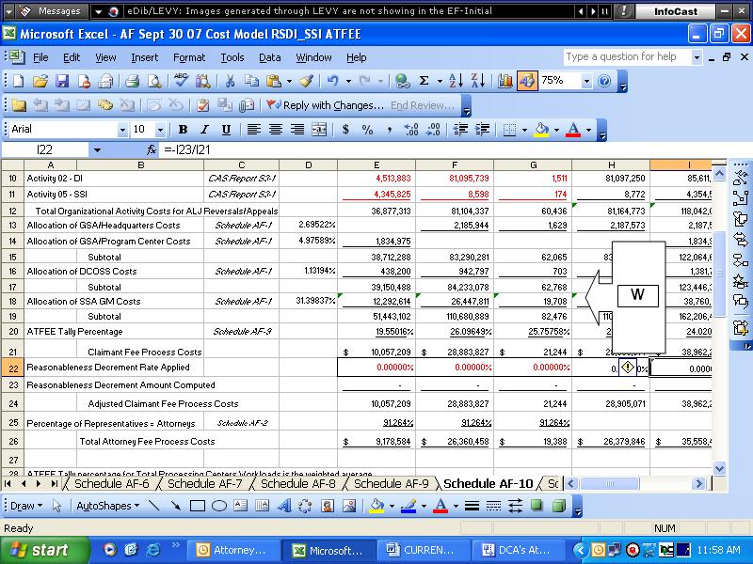
X: Calculate a total PSC, ODO, and OIO cost for the attorney fee process. This calculation will provide the total costs associated with these claims for the Processing Centers by including cost incurred by support staff and GSA to assist in this process.

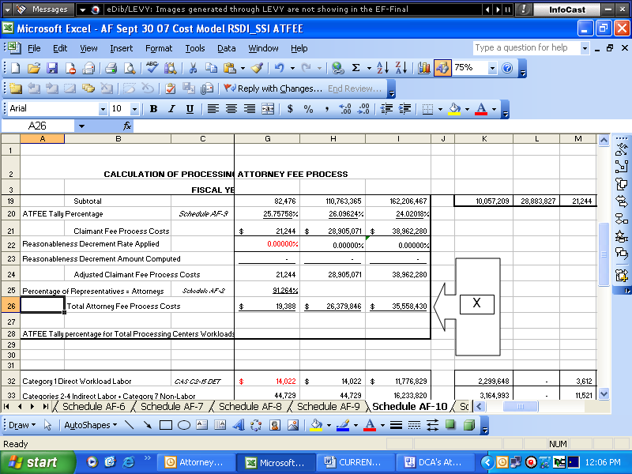

Schedule AF- 11: Summary of Combined Costs to Administer the Attorney Fee Process

Y: Add the total attorney fee process costs for RC-S (schedule AF-4), ODAR (schedule AF-7), PSC, ODO, and OIO (schedule AF-10) to determine the total agency cost for the attorney fee process.

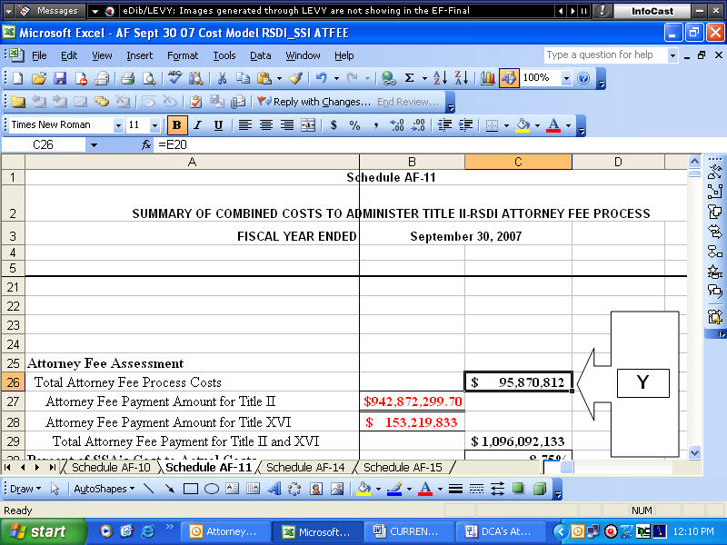

Z: Identify the total attorney fee payment amounts for Title II and Title XVI using the Office of Finance (OF) payment schedules spreadsheets.

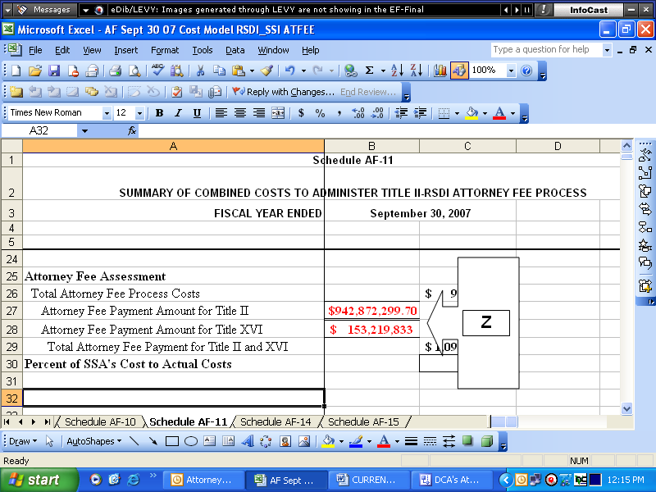
AA: Determine the percent of SSA total process costs to SSA total payment costs. Note: Section 406 of the Ticket to Work and Work Incentives Improvement Act of 1999, established a user fee for the services required to determine and certify payments directly to attorneys for their claimant representative services. Congress set the user fee “not-to-exceed” 6.3 percent of the amount of the fee certified for payment to the attorney in order to obtain full recovery of its costs.

